**Two Trees Extra Virgin Olive Oil**

**Report on shampoo volume in Northeastern and Mid-Atlantic states**

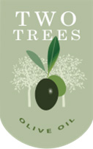Two Trees shampoo products continue to sell very well on the east coast, led by New York State and Vermont. The products leading the way are First Pressed Shampoo for dry hair, Extra Virgin Shampoo for dry scalp and Garlic Infused Olive Oil Shampoo which recently had a cross promotion with Herbed Pasta Conditioner. Trust us, it was delicious.

But a picture is worth a thousand orzo grains, so here is a direct, side-by-side comparison of states contributing to our east coast volume. Numbers are in millions of gallons.